Theory:
Cross-correlation and autocorrelation are mathematical operations used to measure the similarity between signals as a function of the displacement (lag) of one relative to the other. They are widely used in various applications, such as signal processing, pattern recognition, and radar detection.

- Cross-correlation calculates the sum of element-wise products of two different signals as one slides over the other, helping to identify similarities, time delays, or phase shifts between them.

- Autocorrelation, on the other hand, calculates the cross-correlation of a signal with a delayed version of itself. It is commonly used for periodic or noisy signals to find repeating patterns or identify the fundamental frequency.

Flowchart:
The flowchart for the program will consist of the following steps:
- Define two discrete-time signals (signal 1 and signal 2).
- Compute the cross-correlation of the two signals using numpy.correlate.
- Compute the autocorrelation of the first signal using numpy.correlate against itself.
- Plot and display the cross-correlation and autocorrelation results.

Code:
import numpy as np
import matplotlib.pyplot as plt

def compute_cross_correlation(signal1, signal2):
# Compute the cross-correlation
cross_corr = np.correlate(signal1, signal2, mode='full')
return cross_corr

def compute_autocorrelation(signal1):
# Compute the autocorrelation (cross-correlation with itself)
auto_corr = np.correlate(signal1, signal1, mode='full')
return auto_corr

# Define the discrete-time signals
signal1 = np.array([1, 2, 3, 4, 5])
signal2 = np.array([2, 4, 6, 8, 10])

# Compute the cross-correlation
cross_corr = compute_cross_correlation(signal1, signal2)

# Compute the autocorrelation
auto_corr = compute_autocorrelation(signal1)

# Plot the cross-correlation and autocorrelation results
plt.figure(figsize=(10, 6))

plt.subplot(2, 1, 1)
plt.stem(cross_corr)
plt.title('Cross-Correlation')
plt.xlabel('Lag')
plt.ylabel('Amplitude')

plt.subplot(2, 1, 2)
plt.stem(auto_corr)
plt.title('Autocorrelation')
plt.xlabel('Lag')
plt.ylabel('Amplitude')

plt.tight_layout()
plt.show()

Output:
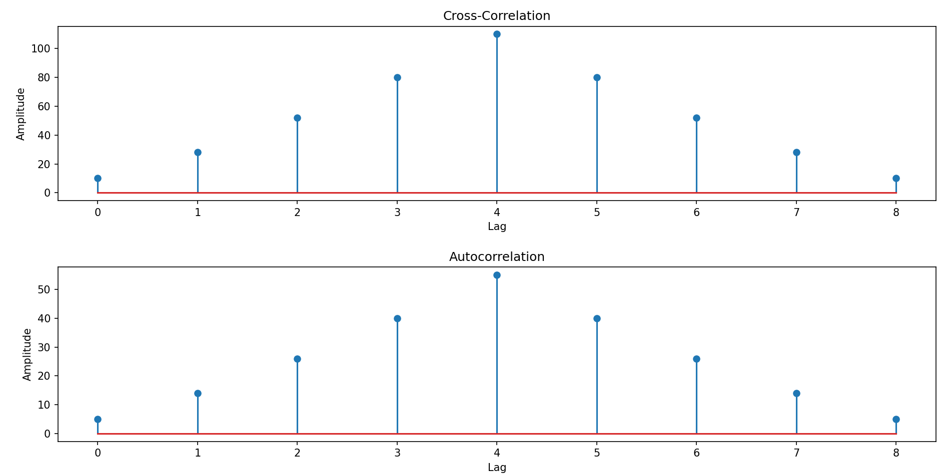
Explanation:

- We import the required modules, including numpy for array operations and matplotlib.pyplot for plotting.
- The compute_cross_correlation function computes the cross-correlation between two signals using numpy.correlate with the mode set to 'full'.
- The compute_autocorrelation function computes the autocorrelation by calculating the cross-correlation of signal1 with itself, also using numpy.correlate with the mode set to 'full'.
- In the main part of the program, we define two discrete-time signals (signal1 and signal2).
- We compute the cross-correlation by calling the compute_cross_correlation function with signal1 and signal2.
- We compute the autocorrelation by calling the compute_autocorrelation function with signal1.
- We plot and display the cross-correlation and autocorrelation results using matplotlib.pyplot.stem.
- The cross-correlation and autocorrelation results can be optionally saved to files using numpy.savetxt.
- You can modify the signal1 and signal2 variables to use different discrete-time signals for correlation.
- Uncomment the np.savetxt lines if you want to save the cross-correlation and autocorrelation results to text files.
- Make sure you have numpy and matplotlib installed (pip install numpy matplotlib) before running this program.

Expected Output:

- A plot will be displayed showing the cross-correlation and autocorrelation results.
- The cross-correlation and autocorrelation results will be saved to text files (optional).
- Feel free to experiment with different discrete-time signals and observe the cross-correlation and autocorrelation outputs.

Github Link: https://github.com/SlockAhuja/DSIP.git

